Tab 1

Objective Questions

Q1. What is the distribution of account balances across different regions?

Sol:
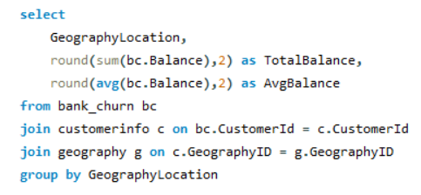

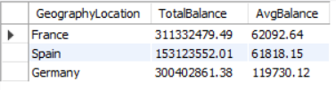
Insights:
- Germany’s average balance (119.7K) is nearly 2x that of Spain and France (~62K). This indicates a financially stronger customer base with higher deposit capacity.
- France has the highest total balance (311M). Even though the average balance is moderate, the sheer number of customers is strong, driving up total deposits.
- Spain contributes the lowest total balance (153M) along with similar average balances to France. This indicates Spain may have:
  - Lower customer count, or
  - Lower deposit behaviour.
Recommendations :

Germany Should Be Treated as a High-Value, High-Priority Segment

France Needs Customer Volume-Based Retention Strategy

Spain Requires Deposit-Growth Initiatives

Q2. Identify the top 5 customers with the highest Estimated Salary in the last quarter of the year. (SQL)

Sol:
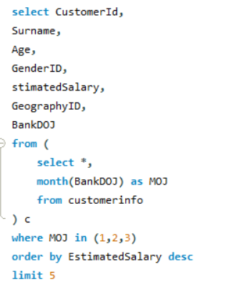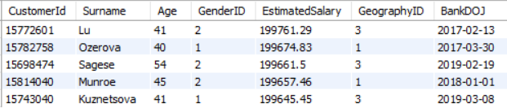

Insights:
- The top five customers with the highest estimated salaries also demonstrate longer tenures, suggesting a potential link between income level and sustained loyalty to the bank.
- The narrow variation in estimated salaries among these customers indicates a highly consistent high-income segment, implying similar financial characteristics across the top-performing group.
- Customers who joined the bank earlier—such as Lu and Ozerova—rank higher in salary, reinforcing the idea that long-term customers may have grown their wealth over time while remaining actively engaged with the bank.
- All customers on the list joined between 2017 and 2019, reflecting a period of stable and effective acquisition of high-salary clients.
Recommendations :
- Prioritize retention strategies for high-salary customers, as this segment demonstrates strong loyalty and presents significant long-term value for the bank.
- Develop exclusive, premium offerings tailored to high-earning customers, such as priority services or curated financial products, to deepen engagement and strengthen loyalty.
- Leverage these insights to design targeted, personalized marketing campaigns aimed at similar high-salary profiles who exhibit long-term customer traits.
- Continuously track salary patterns among newly onboarded customers to ensure the bank maintains a pipeline of high-earning individuals, and adapt acquisition strategies as needed to sustain this momentum.

Q3. Calculate the average number of products used by customers who have a credit card. (SQL)

Sol:
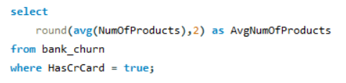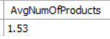

Insights:
- Customers with CreditID 1—those who hold a credit card—use an average of 1.53 products, indicating that most credit card holders are actively using only one to two banking products.
- This limited average utilization highlights an under-engagement with the bank’s broader product portfolio, suggesting that many credit card customers are not fully exploring additional services.
- The narrow distribution of product usage further points to low product diversity within this customer segment.
- This pattern suggests a strong opportunity for the bank to expand engagement by positioning complementary financial products to credit card users.
Recommendations :
- Launch targeted cross-selling initiatives for credit card customers to promote complementary offerings such as loans, savings products, insurance, or investment plans.
- Investigate key drivers behind the low product adoption rate, including customer awareness, perceived relevance, or onboarding gaps, and address these barriers systematically.
- Introduce personalized product recommendations or tailored incentives to encourage credit card holders to deepen their relationship with the bank and increase their product usage.
- Segment credit card customers based on their current usage patterns and deploy focused marketing strategies for those engaging with only one or two products to enhance adoption levels.

Q4. Determine the churn rate by gender for the most recent year in the dataset.

Sol:
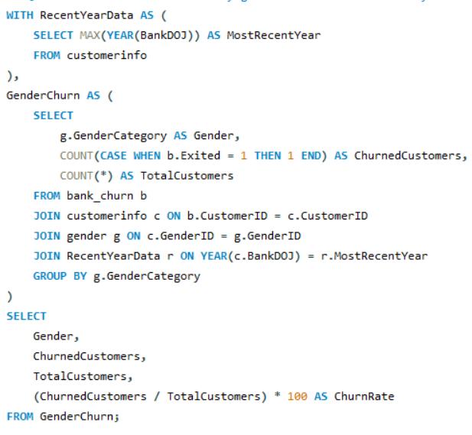

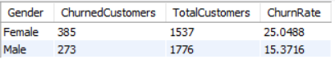

Insights:
- Female customers exhibit a notably higher churn rate (25.05%) compared to male customers (15.37%), indicating that women are more likely to discontinue their relationship with the bank.
- Although the number of female customers is slightly lower than males, the disproportionately higher churn level signals potential dissatisfaction or unmet expectations among female clients.
- The analysis leverages customers who joined in the most recent year (based on BankDOJ), providing a current and accurate reflection of churn dynamics.
- Gender emerges as an influential driver of churn behavior, suggesting that differences in customer experience, product engagement, or service quality may be affecting female customers more significantly.
Recommendations :
- Conduct targeted research, such as surveys or focused interviews, to identify the underlying reasons behind the higher churn among female customers and capture their expectations more accurately.
- Design and implement women-centric retention strategies, including personalized product bundles, loyalty benefits, financial wellness programs, or enhanced support touchpoints.
- Track gender-specific churn trends on an ongoing basis to measure the impact of interventions and recalibrate retention initiatives accordingly.
- Leverage these findings to strengthen customer segmentation models and develop more precise marketing and engagement strategies tailored specifically to female customers.
Q5. Compare the average credit score of customers who have exited and those who remain. (SQL)

Sol:
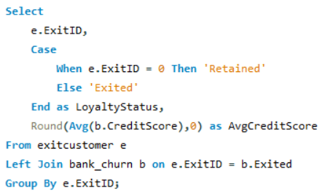

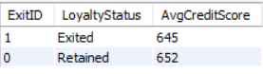

Insights:
- Retained customers have an average credit score of 652, which is marginally higher than the 645 average credit score of customers who exited.
- Although the difference is not substantial, the slight variation may suggest a weak correlation between credit score and customer loyalty.
- The ExitID parameter effectively distinguishes churned customers (ExitID = 1) from active ones (ExitID = 0), enabling a clearer understanding of loyalty patterns.
- The narrow difference in credit scores indicates that credit score alone is not a strong predictor of churn, implying that other behavioural or service-related factors likely influence customer decisions.
Recommendations :
- Explore additional churn drivers such as customer satisfaction scores, product adoption levels, service experience, or interaction quality to identify stronger predictors of churn.
- Design focused retention strategies for customers with credit scores close to the 645 range, as this segment may represent a slightly higher churn risk.
- Proactively engage customers with lower credit scores through personalized advisory services, financial literacy programs, or loyalty incentives to strengthen their relationship with the bank.
- Enhance customer segmentation models by incorporating behavioural and engagement-based metrics—not just credit scores—for a more holistic and accurate churn prediction framework.
Q6. Which gender has a higher average estimated salary, and how does it relate to the number of active accounts? (SQL)

Sol:
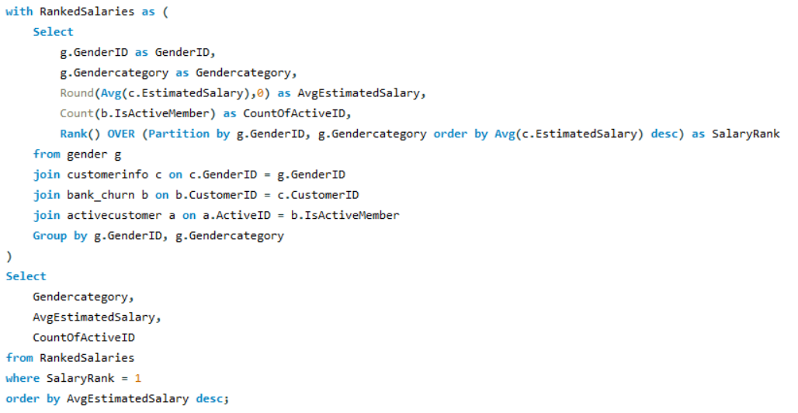
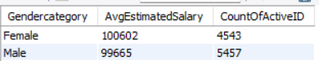
Insights:
- Female customers show a slightly higher average estimated salary (100,602) compared to male customers (99,665), reflecting only a marginal income variation between genders.
- Despite the higher income, female customers maintain fewer active accounts (4,543) compared to male customers (5,457), which may indicate lower engagement with the bank’s product portfolio.
- The application of RANK() across gender categories reinforces that estimated salaries between men and women are closely aligned, with females slightly ahead.
- Given the minimal salary difference, other behavioural or preference-based factors may be influencing lower product engagement among female customers.
Recommendations :
- Conduct a deeper analysis to understand the drivers behind lower product usage among female customers, despite their slightly higher income levels.
- Implement gender-focused engagement campaigns, encouraging female customers to explore a wider range of banking products and increase their activity levels.
- Offer personalized financial solutions, exclusive benefits, or advisory services targeted at high-earning customers—particularly females—to enhance retention and product adoption.
- Evaluate additional behavioural metrics beyond salary, such as digital activity, service interactions, or product awareness, to design more effective gender-based marketing and engagement strategies.
Q7. Segment the customers based on their credit score and identify the segment with the highest exit rate. (SQL)

Sol:
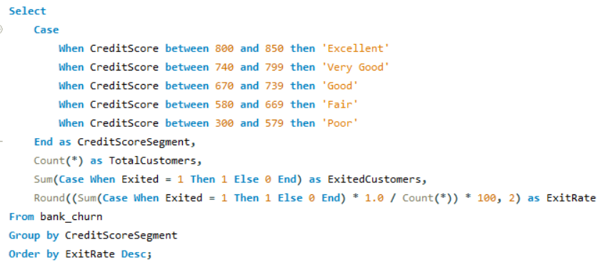

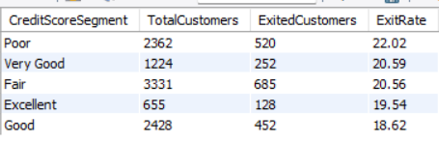
Insights:
- Customers in the “Poor” credit score segment (300–579) show the highest churn rate at 22.02%, indicating they are significantly more likely to exit the bank compared to other segments.
- The “Very Good” (740–799) and “Fair” (580–669) categories also display elevated exit rates at 20.59% and 20.56%, highlighting emerging risk within these groups.
- The segment with the lowest churn rate is “Good” (670–739) at 18.62%, followed by the “Excellent” (800–850) segment with a churn rate of 19.54%.
- Overall, churn is notably higher among customers with lower credit scores (“Poor” and “Fair”), which may point to financial instability, dissatisfaction with products, or limited financial resilience.
Recommendations :
- Prioritize retention initiatives for the “Poor” and “Fair” credit segments, offering tailored interventions such as financial counselling, credit-building tools, and personalized product recommendations.
- Introduce loyalty incentives for “Very Good” and “Fair” segment customers, such as preferential rates, bonus reward programs, or exclusive service benefits to reduce churn risk.
- Launch targeted engagement campaigns aimed at enhancing satisfaction and educating lower credit score customers about suitable product options.
- Implement proactive monitoring and early-warning outreach programs for high-risk segments—particularly those in the “Poor” category—to address emerging concerns before customers choose to exit.
Q8. Find out which geographic region has the highest number of active customers with a tenure greater than 5 years. (SQL)

Sol:
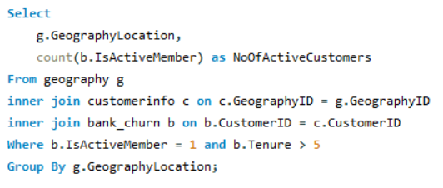

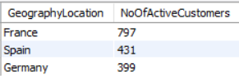

Insights:
- France leads with 797 active customers having tenures above five years, significantly higher than Spain (431) and Germany (399). This indicates a substantially stronger long-term customer base in the French market.
- The large gap between France and the other regions suggests that French customers exhibit higher loyalty and sustained engagement with the bank’s offerings.
- Spain and Germany show comparable levels of long-tenured active customers, indicating similar engagement patterns in these two regions.
- The strong performance in France may be the result of superior customer experience, stronger product-market fit, or more effective relationship management practices compared to other regions.
Recommendations :
- Conduct a root-cause analysis to understand the drivers behind France’s exceptional retention performance, and replicate these best practices across other regions.
- Strengthen customer engagement strategies in Spain and Germany, with a focus on nurturing customers early in their lifecycle to increase long-term retention.
- Introduce targeted loyalty programs and tenure-based incentives in Spain and Germany to encourage customers to remain active and expand their use of bank products.
- Continuously track customer satisfaction and service quality benchmarks across all regions to identify gaps and implement consistent retention-improvement initiatives.
Q9. What is the impact of having a credit card on customer churn, based on the available data?

Sol:
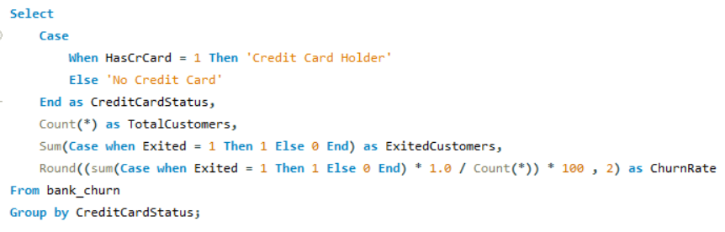

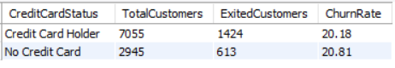
Insights:
- Customers without a credit card exhibit a slightly higher churn rate (20.81%) compared to those with a credit card (20.18%), though the difference is marginal.
- The small variance suggests that credit card ownership is not a major driver of churn, and other underlying factors may be influencing customer exits.
- A significantly larger portion of the customer base—7,055 customers—holds credit cards, compared to 2,945 customers who do not, indicating strong adoption of credit card products.
- Despite the higher churn rate among non–credit card holders, the overall similarity in churn percentages implies that credit card usage alone does not substantially impact customer retention.
Recommendations :
- Deep-dive into customer satisfaction insights to uncover the true drivers behind churn, such as service challenges, product limitations, or unmet customer expectations.
- Introduce personalized incentives or educational campaigns to promote credit card adoption among non–credit card customers, potentially strengthening their engagement with the bank.
- Deploy targeted retention initiatives for both segments, focusing on proactive outreach and addressing customer pain points before they lead to attrition.
- Continuously track churn trends across both cohorts and recalibrate strategies based on evolving customer behaviours and engagement patterns.
Q10. For customers who have exited, what is the most common number of products they have used?

Sol:
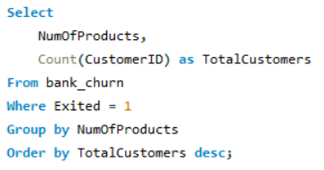

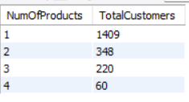

Insights:
- A large proportion of exited customers—1,409 individuals—were associated with only one product, making it the most impacted segment.
- In contrast, significantly fewer exited customers were engaged with multiple products: 348 with two products, 220 with three products, and only 60 with four products.
- This pattern strongly suggests a correlation between low product engagement and higher churn propensity. Customers with limited product adoption appear more vulnerable to attrition.
- The sharp decline in customer count as product usage increases indicates that multi-product penetration remains limited, highlighting an opportunity to improve cross-product engagement.
Recommendations :
- Prioritize cross-sell initiatives for single-product customers, as expanding their product portfolio can materially enhance engagement and reduce churn risk.
- Deploy targeted, data-driven marketing campaigns that nudge at-risk customers toward adopting additional products, with messaging tailored to their needs and usage patterns.
- Conduct a root-cause assessment to understand why customers remain on a single product—whether due to lack of awareness, perceived complexity, or product relevance—and design interventions to address these barriers.
- Introduce incentive-based bundling or loyalty programs to motivate customers to explore additional banking solutions, thereby deepening their relationship with the bank and improving overall retention.
Q11. Examine the trend of customers joining over time and identify any seasonal patterns (yearly or monthly). Prepare the data through SQL and then visualize it.

Sol:
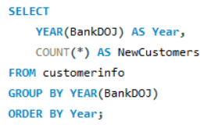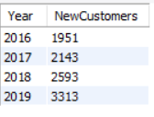

Insights:
- The data reflects a steady upward trajectory in customer acquisition from 2016 through 2019, signalling strong and sustained growth momentum.
- 2019 recorded the highest influx of new customers (3,313), indicating a substantial uplift—potentially driven by enhanced marketing initiatives, product improvements, or an improved customer experience strategy.
- The year-over-year growth rate is accelerating, which demonstrates increasing market traction and effective acquisition frameworks.
- Broader economic or market dynamics during this period may also have contributed to the rising customer onboarding volume.
Recommendations :
- Deep-dive into the drivers behind the 2019 acquisition surge, and replicate the most impactful levers across upcoming campaigns.
- Sustain and scale high-performing acquisition strategies, with a focus on refining customer targeting, channel optimization, and value proposition alignment.
- Perform a granular month-level analysis to uncover potential seasonality patterns or campaign-driven spikes that can inform future planning.
- Utilize these insights to forecast acquisition trends and proactively align marketing, resource planning, and customer onboarding initiatives with expected growth.
Q12. Analyze the relationship between the number of products and the account balance for customers who have exited.

Sol:
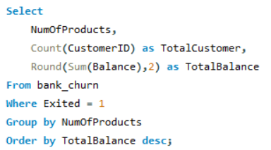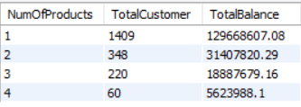

Insights:
- Customers who use only one product hold the highest total balance of 129,668,607.08, substantially surpassing all other product-usage segments.
- As product usage increases, overall balance contribution declines, with the four-product segment contributing the lowest balance at 5,623,988.10.
- Although the number of customers using three or four products is comparatively low, these segments collectively contribute significantly less to the bank’s total balance.
- The trend clearly indicates that customers with fewer products maintain higher account balances, whereas multi-product customers tend to hold relatively lower balances.
Recommendations :
- Conduct a detailed assessment to understand why customers with higher product penetration exhibit lower balances, and identify potential barriers to deeper financial engagement.
- Develop strategic cross-sell pathways for one-product customers—ensuring they adopt additional products without compromising their high balance levels, possibly through curated bundles or premium value propositions.
- Engage low-balance, multi-product customers with targeted financial growth programs, designed to enhance both balance levels and product utilization effectiveness.
- Implement high-touch retention initiatives for high-balance, single-product customers, as they represent a substantial share of the bank’s total balance despite limited portfolio diversification.
Q13. Identify any potential outliers in terms of balance among customers who have remained with the bank.

Sol: Methods to Identify Outliers:
- Z-Score Method:
  - Formula: Z = (X − μ) / σ
  - Outliers are those data points where Z > 3 or Z < -3 (threshold can be adjusted depending on the dataset).
- Interquartile Range (IQR) Method:
  - Formula: IQR = Q3 − Q1
  - Outliers are values < Q1 − 1.5 × IQR or > Q3 + 1.5 × IQR.
- Box Plot Visualization:
  - Outliers are represented as points outside the "whiskers" (typically 1.5 times the IQR) in a box plot.

Applying Outlier Detection:

- Z-Score Calculation:
  - Identify balances with Z-Scores outside the range [-3, 3].
- IQR Calculation:
  - Identify balances below Q1 − 1.5 × IQR or above Q3 + 1.5 × IQR.
- Handling Outliers:
  - Remove Outliers:
  - Remove data points that are extreme or suspected errors.
- Transform Data:
  - Apply transformations (e.g., log transformation) to reduce the impact of extreme values.
- Cap/Floor:
  - Set upper and lower limits for values based on a reasonable threshold.

By using these methods, we can effectively identify and handle outliers to ensure accurate data analysis.
Q14. How many different tables are given in the dataset, out of these tables which table only consists of categorical variables?

Sol: The dataset consists of 7 tables. Out of these, the following 5 tables contain only categorical variables:
- activecustomer
  - ActiveID (INT)
  - ActiveCategory (TEXT)
- creditcard
  - CreditID (INT)
  - Category (TEXT)
- exitcustomer
  - ExitID (INT)
  - ExitCategory (TEXT)
- gender
  - GenderID (INT)
  - GenderCategory (TEXT)
- geography
  - GeographyID (INT)
  - GeographyLocation (TEXT)

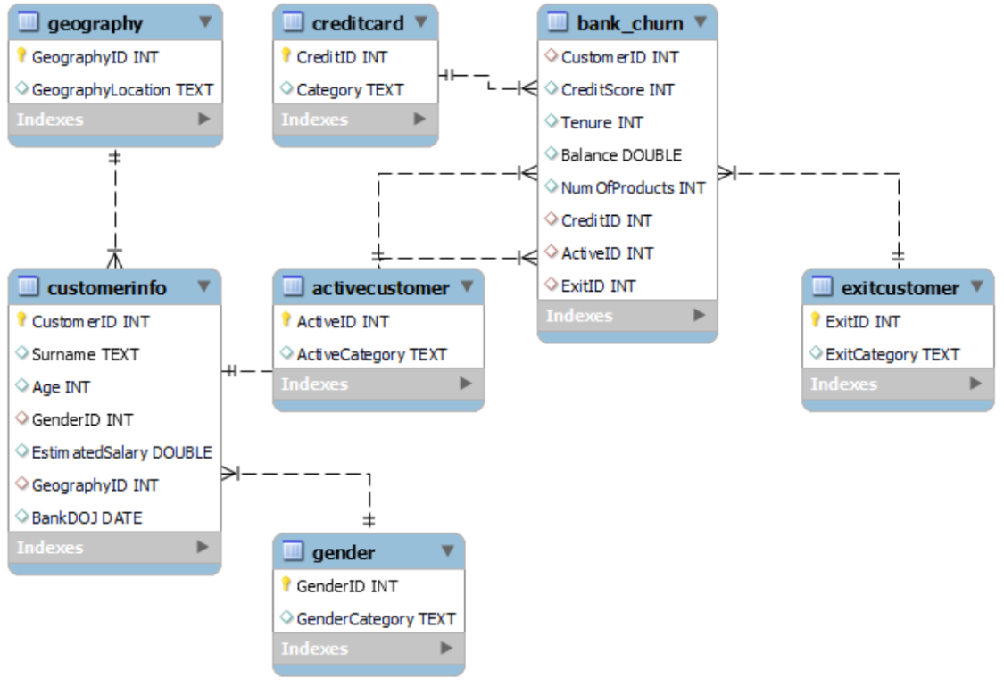
Q15. Using SQL, write a query to find out the gender-wise average income of males and females in each geography id. Also, rank the gender according to the average value. (SQL)

Sol:
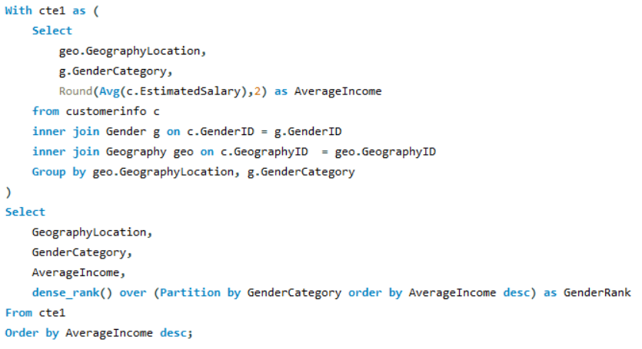
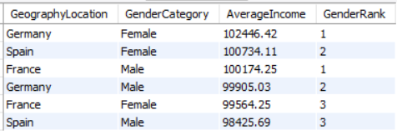
Insights:
- The query outlines the gender-wise average income across various geographies, enabling a clear view of regions where one gender earns notably more than the other.
- The ranking mechanism highlights income differences between males and females within each geography, providing visibility into gender-based earning patterns.
- Certain regions, such as Germany and Spain, indicate higher average incomes for females, while other geographies reflect comparatively stronger male income levels.
- Identifying regions with pronounced gender income gaps helps pinpoint areas that may require deeper analysis to understand underlying socio-economic or market-driven factors.
Recommendations :
- Prioritize geographies with significant gender-based income disparities and implement initiatives or inclusive financial solutions aimed at promoting income equity.
- Examine the drivers behind higher income levels for specific genders in certain regions and replicate these effective practices in locations where income levels lag.
- Leverage gender-specific income insights to design customized financial products, thereby enhancing engagement and customer satisfaction.
- Continuously track geographic and gender-based income trends to evaluate the effectiveness of implemented interventions and refine strategies accordingly.
Q16. Using SQL, write a query to find out the average tenure of the people who have exited in each age bracket (18-30, 30-50, 50+).

Sol:
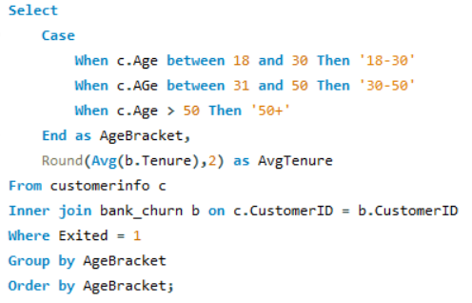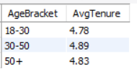

Insights:
- Customers in the 30–50 age segment demonstrate the highest average tenure before exiting, at 4.89 years, compared to 4.78 years for the 18–30 segment and 4.83 years for those aged 50+.
- The 30–50 age bracket appears to maintain a longer relationship with the bank prior to churn, indicating deeper engagement before disengagement occurs.
- The 18–30 customer group shows the shortest tenure, signalling that younger customers are more likely to churn earlier in their lifecycle.
- Overall, the tenure variance across age groups is relatively small, suggesting that churn behaviour is fairly consistent across demographics, with only subtle differences.
Recommendations :
- Prioritize retention initiatives for the 18–30 customer segment by introducing youth-centric offerings, digital-first experiences, and value-added services to increase longevity.
- Explore the underlying reasons why customers in the 30–50 age group exit despite longer tenures, and design targeted interventions to extend their lifecycle further.
- For the 50+ demographic, strengthen loyalty by promoting retirement-focused products, long-term investment plans, and advisory services tailored to their financial goals.
- Conduct deeper churn diagnostics across all age categories to uncover behavioural drivers and build more precise, age-specific retention frameworks.
Q17. Is there any direct correlation between salary and the balance of the customers? And is it different for people who have exited or not?

Sol:
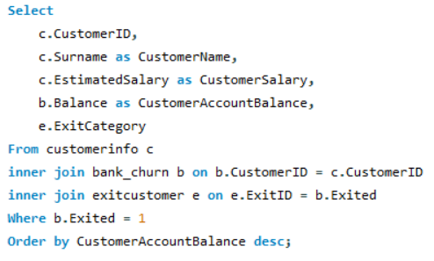
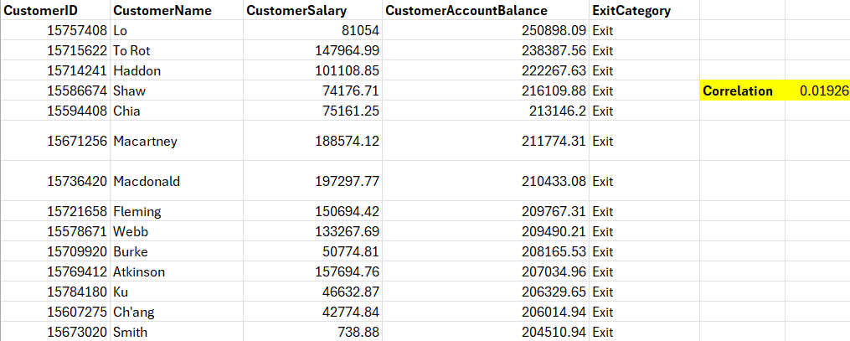

Insights:
- The correlation between estimated salary and account balance among exited customers is extremely weak (R² = 0.01926), indicating that salary has minimal influence on balance levels within this group.
- Higher salaries do not translate into higher account balances for customers who have churned, suggesting that income is not a determining factor in their financial engagement.
- This pattern implies that other variables—such as product usage, credit profile, or customer experience—may play a more significant role in shaping account balances for exited customers.
Recommendations :
- Conduct a comparative analysis for active customers to determine whether the salary–balance relationship behaves differently among retained segments.
- Prioritize retention strategies that strengthen product engagement and customer interaction, as salary alone is not a reliable indicator of balance growth.
- Deep-dive into additional behavioural and financial factors—such as product portfolios, credit scores, and transaction patterns—to identify actionable drivers that can help increase account balances and reduce churn risk.
Q18. Is there any correlation between the salary and the Credit score of customers?

Sol:
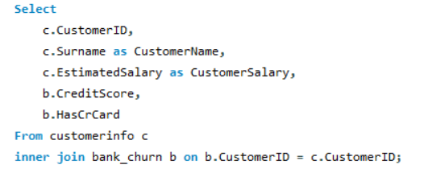
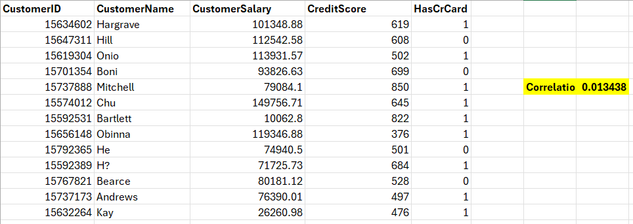

Insights:
- The relationship between salary and credit score is extremely weak for both credit card holders and non-holders, with R² values close to 0.01.
- This minimal correlation suggests that income level does not significantly influence a customer’s credit score.
- The similarity in correlation patterns across both customer groups indicates that credit scores are shaped more by behavioural and historical credit factors than by earnings.
Recommendations :
- Shift analytical focus to factors like repayment behaviour, credit utilization, and credit history, as these are more reliable predictors of credit score variation.
- Promote financial literacy initiatives to help customers strengthen their credit profiles regardless of income.
- Develop customized financial products and advisory solutions targeted at both high and low credit score segments to enhance engagement and improve overall portfolio quality.
Q19. Rank each bucket of credit score as per the number of customers who have churned the bank.

Sol:
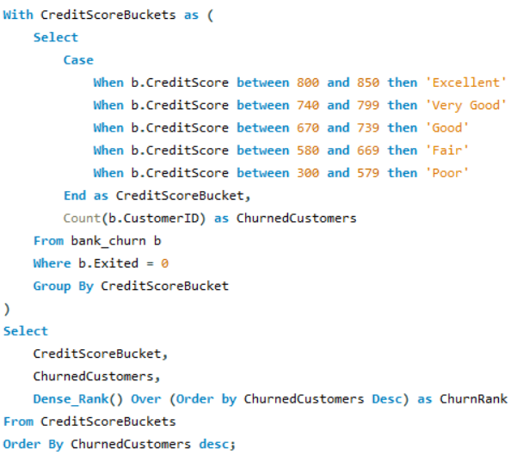
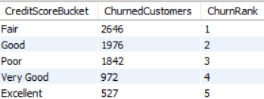

Insights:
- Customers in the “Fair” credit score segment show the highest churn, with 2,646 exits, indicating that this group is particularly susceptible to leaving the bank.
- The “Good” and “Poor” segments follow, highlighting that churn is not limited to low credit score groups—customers with reasonably good scores are also at risk.
- The lowest churn is observed among “Excellent” credit score customers, with only 527 exits, suggesting this group demonstrates stronger loyalty and stability.
- Overall, the data shows a declining churn trend as credit scores improve, indicating a potential relationship between stronger credit profiles and higher customer retention.
Recommendations :
- Deploy focused retention initiatives for customers in the “Fair” and “Good” credit score segments, as they represent the largest at-risk groups.
- Offer personalized solutions, financial guidance, or value-added services to customers with lower credit scores to enhance engagement and reduce churn.
- Strengthen loyalty among “Excellent” credit score customers through exclusive rewards, preferential benefits, or premium service experiences.
- Continuously track credit score movements and identify emerging risk clusters to proactively address customer needs before they decide to exit.
Q20. According to the age buckets find the number of customers who have a credit card. Also retrieve those buckets that have lesser than average number of credit cards per bucket.

Sol:
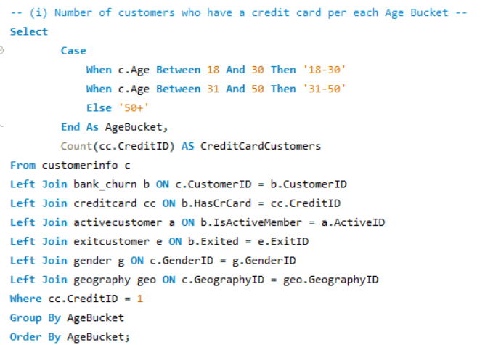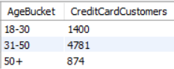
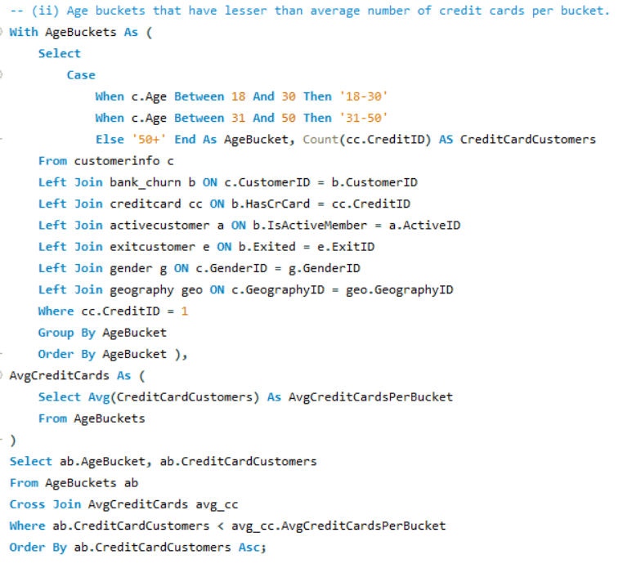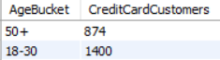

Insights:
- The 31–50 age group has the highest concentration of credit card holders, substantially exceeding all other age brackets.
- Both the 18–30 and 50+ age groups fall below the overall average number of credit card holders, indicating lower engagement in these segments.
- This distribution highlights that middle-aged customers are significantly more active in credit card usage, demonstrating stronger product adoption in this demographic.
- The younger and older customer groups show under-penetration, signaling clear opportunities for targeted marketing and product positioning.
Recommendations :
- Launch age-specific marketing initiatives for customers aged 18–30 and 50+ to drive higher credit card adoption.
- Introduce tailored incentives, rewards, or lifestyle-based benefits designed to resonate with younger and older customer needs.
- Continuously track credit card usage patterns across age segments to identify emerging opportunities and refine product strategies.
- Implement financial literacy and awareness programs for younger customers to build familiarity and confidence in credit products.
Q21. Rank the Locations as per the number of people who have churned the bank and average balance of the customers.

Sol:
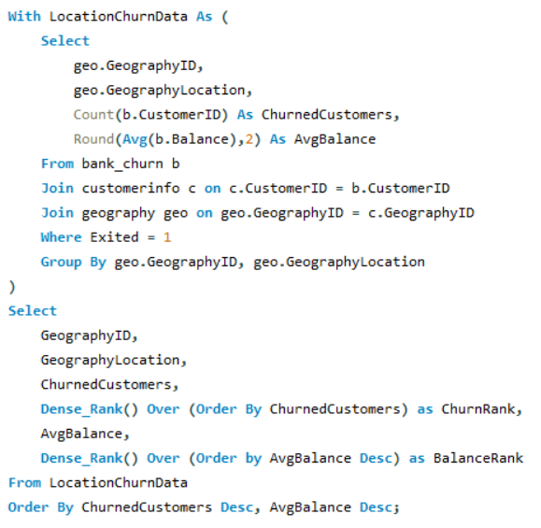

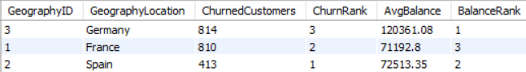
Insights:
- Germany records the highest average balance among churned customers, despite contributing the lowest number of churn cases, indicating that high-value customers are exiting the bank in this region.
- Spain has the smallest churn count yet holds the second-highest average balance, suggesting a comparatively stable and financially strong customer base.
- France shows the highest churn volume but the lowest average balance, pointing to potential dissatisfaction among lower-balance customers.
- Overall, there appears to be an inverse relationship between churn count and average balance, particularly visible when comparing Germany and France.
Recommendations :
- Prioritize retention strategies for high-balance customers in Germany, with enhanced service experience, personalized wealth products, and proactive engagement.
- Conduct a detailed analysis in France to uncover the drivers behind high churn despite lower balances, enabling the bank to address service gaps or unmet customer needs.
- Continue strengthening engagement initiatives in Spain to maintain its low churn levels and potentially convert stable customers into multi-product users.
- Adopt a dual-lens retention approach that considers both average balance and churn volume, ensuring resources are allocated to high-impact customer segments.
Q22. As we can see that the “CustomerInfo” table has the CustomerID and Surname, now if we have to join it with a table where the primary key is also a combination of CustomerID and Surname, come up with a column where the format is “CustomerID_Surname”.

Sol:
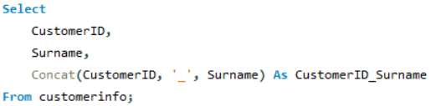

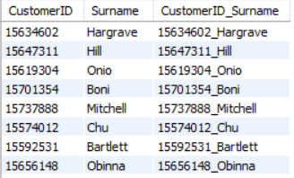
Q23. Without using “Join”, can we get the “ExitCategory” from ExitCustomers table to Bank_Churn table? If yes do this using SQL.

Sol:

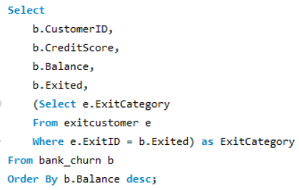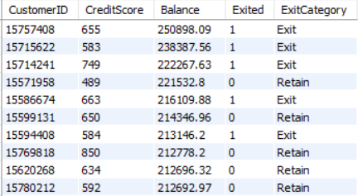
Q24. Were there any missing values in the data, using which tool did you replace them and what are the ways to handle them?

Sol:
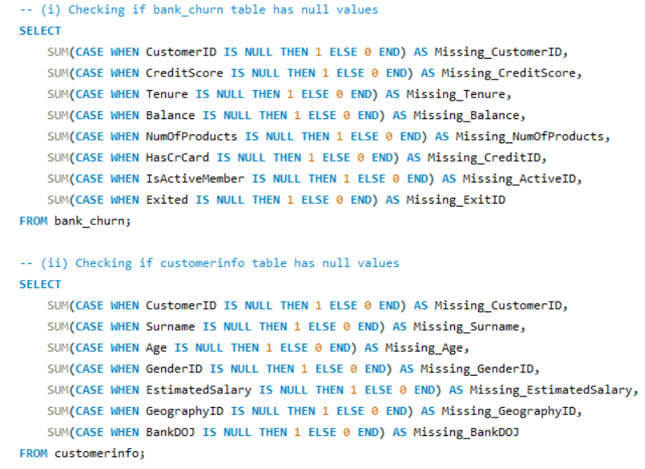

Recommendations :
Currently, there are no missing values in the dataset, as seen from the query results. However, if there were missing values, here are the steps we could take:
- Imputation: We can use techniques such as mean, median, or mode imputation to fill missing values for numerical data. For categorical variables, the most frequent category could be used.
- Deletion: In cases where a few rows have missing data, we can choose to delete those records if the impact on overall analysis is minimal, ensuring we don't lose significant information.
- Interpolation or Forward Filling: For time-series data, we can interpolate or use forward/backward filling techniques to estimate missing values based on neighbouring records.

Q25. Write the query to get the customer IDs, their last name, and whether they are active or not for the customers whose surname ends with “on”.

Sol:
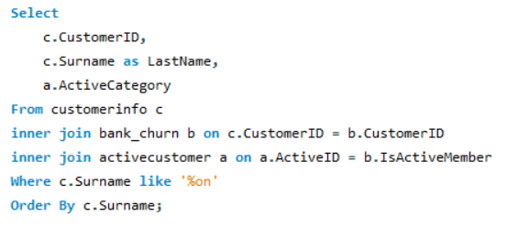
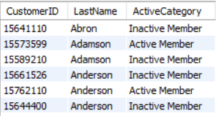

Q26. Can you observe any data disrupency in the Customer’s data? As a hint it’s present in the IsActiveMember and Exited columns. One more point to consider is that the data in the Exited Column is absolutely correct and accurate.

Sol:
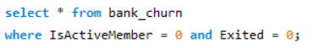
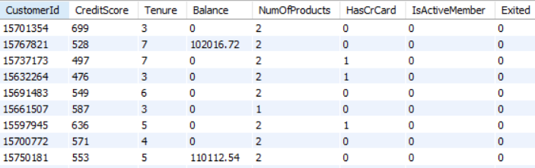

Observations:
- Conflicting Status Flags (ActiveID vs ExitID):
The dataset contains customers tagged simultaneously with ActiveID = 1 and ExitID = 1. This represents a clear logical contradiction, as a customer cannot be classified as “active” and “exited” at the same time. Such inconsistencies usually indicate data-entry errors, flawed update workflows, or gaps introduced during system migration.
- Zero Balance but Active/Exited:
Several customer records show a zero account balance while still being marked as active or even having exited with active products assigned. This highlights potential delays in balance reconciliation or incomplete account-closure procedures.
- Multiple Products with Zero Balance:
Some customers have NumOfProducts > 1 yet maintain a balance of zero. This may suggest dormant or inactive products that were never deactivated in the system. It also reflects inadequate product-level lifecycle management.
Recommendations :
- Deploy Automated Data Integrity Checks:
Implement automated validation scripts to flag impossible combinations—such as customers marked as both active and exited—before the data enters analytical workflows or downstream systems.
- Strengthen Customer Exit Workflows:
Ensure that customer status is consistently and automatically updated during the exit process. The system should enforce setting ActiveID = 0 upon exit to prevent contradictory states.
- Enhance Reconciliation for Balances and Products: Introduce systematic checks to verify that:
- All active customers have accurate balances
- Exited customers have zero balance
- Product assignments are updated in real time when a customer exits or becomes inactive
Review System Triggers and Migration Logic:
Conduct a root-cause analysis on the underlying processes that update account status, balances, and product ownership. Potential issues may include:
- Outdated triggers
- Manual overrides
- Batch updates failing silently
- Migration scripts not aligning with current data governance standards

